A PROJECT REPORT ON

Smart Canteen Management System

**Submitted in partial fulfilment for the award of the degree of**

## BACHELOR OF TECHNOLOGY

**In**

## Computer Science and Technology

**By**

**P. Praneetha (21A81A0657) G.S.Prabhu Kiran (21A81A0612) P.Vasu (22A85A0605)**

**N.Charles Bunny (21A81A0649)**

**P.Vasantha (21A81A0656)**

**Under the Esteemed Supervision of Dr. K. Srinivasa Rao Assistant Professor**



**Department of Computer Science and Engineering (Accredited by N.B.A.)**

**SRI VASAVI ENGINEERING COLLEGE(Autonomous)**

**(Affiliated to JNTUK, Kakinada) Pedatadepalli, Tadepalligudem-534101, A.P 2023-24**

## SRI VASAVI ENGINEERING COLLEGE (Autonomous)

#### Department Of Computer Science and Technology

##### Pedatadepalli, Tadepalligudem





This is to certify that the Project Report entitled **“Smart Canteen Management System”** submitted by **P.PRANEETHA (21A81A0657)** for the award of the degree of Bachelor of Technology in the Department of Computer Science and Technology during the academic year 2023-2024.

|  |  |
| --- | --- |
| **Name of Project Guide**  Dr. K. Srinivasa Rao Assistant Professor | **Head of the Department**  Dr. D. Jaya Kumari M.Tech.,Ph.D..  Professor & HOD. |

#### External Examiner

**DECLARATION**

We hereby declare that the project report entitled “Smart Canteen Management System" submitted by us to Sri Vasavi Engineering College(Autonomous), Tadepalligudem, affiliated to JNTUK Kakinada in partial fulfilment of the requirement for the award of the degree of B.Tech in Computer Science and Engineering is a record of Bonafide project work carried out by us under the guidance of **Dr**. **K. Srinivasa Rao, Assistant Professor**. We further declare that the work reported in this project has not been submitted and will not be submitted, either in part or in full, for the award of any other degree in this institute or any other institute or University.

#### Project Associates

P.Praneetha (21A81A0657) G.S.Prabhu Kiran (21A81A0612) P.Vasu (22A85A0605)

N.Charles Bunny (21A81A0649) P.Vasantha (21A81A0656)

**ACKNOWLEDGEMENT**

First and foremost, we sincerely salute to our esteemed institute **SRI VASAVI ENGINEERING COLLEGE,** for giving us this golden opportunity to fulfill our warm dream to become an engineer.

Our sincere gratitude to our project guide **Dr. K. Srinivasa Rao,** Assistant Professor, Department of Artificial Intelligence and Machine Learning**,** for his timely cooperation and valuable suggestions while carrying out this project.

We express our sincere thanks and heartful gratitude to **Dr. D. Jaya Kumari**, Professor & Head of the Department of Computer Science and Engineering, for permitting us to do our project.

We express our sincere thanks and heartful gratitude to **Dr. G.V.N.S.R. Ratnakara Rao**, Principal, for providing a favourable environment and supporting us during the development of this project.

Our special thanks to the management and all the teaching and non-teaching staff members, Department of Computer Science and Engineering, for their support and cooperation in various ways during our project work. It is our pleasure to acknowledge the help of all those respected individuals.

We would like to express our gratitude to our parents, friends who helped to complete this project.

#### Project Associates

P.Praneetha (21A81A0657) G.S.Prabhu Kiran (21A81A0612) P.Vasu (22A85A0605)

N.Charles Bunny (21A81A0649) P.Vasantha (21A81A0656)

**TABLE OF CONTENTS**

|  |  |  |
| --- | --- | --- |
| **S.NO** | **TITLE** | **PAGE NO** |
| 1 | **INTRODUCTION** | **1-2** |
|  | 1.1 Introduction | 2 |
|  | 1.2 Objective | 2 |
|  | 1.3 Scope | 2 |
| 2 | **LITERATURE SURVEY** | **3-5** |
| 3 | **SYSTEM STUDY AND ANALYSIS** | **6-11** |
|  | 3.1 Problem Statement | 7 |
|  | 3.2 Existing System | 7 |
|  | 3.3 Limitations of the Existing System | 7 |
|  | 3.4 Proposed System | 8 |
|  | 3.5 Advantages of Proposed System | 8 |
|  | 3.6 Functional Requirements | 8-9 |
|  | 3.7 Non-Functional Requirements | 9 |
|  | 3.8 System Requirements | 9-10 |
|  | 3.8.1 Software Requirements | 11 |
|  | 3.8.2 Hardware Requirements | 11 |
| 4 | **SYSTEM DESIGN** | **12-18** |
|  | 4.1 System Architecture Design | 13 |
|  | 4.2 UML Diagrams | 13-18 |
| 5 | **MODULES** | **19-21** |
|  | 5.1 Canteen Management | 20 |
|  | 5.2 Sales | 20 |
|  | 5.3 Customer | 20 |
|  | 5.4 Employee Management | 20 |
|  | 5.5 Item | 20 |
|  | 5.6 Stock | 20-21 |
|  | 5.7 Login | 21 |
|  | 5.8 Users | 21 |
| 6 | **TECHNOLOGIES** | **22-26** |
|  | 6.1 HTML | 23-24 |
|  | 6.2 CSS | 24-25 |
|  | 6.3 Django Framework | 25 |
|  | 6.4 PHP | 25-26 |
| 7 | **IMPLEMENTATION** | **27-33** |
|  | 7.1 Coding | 28-33 |
| 8 | **TESTING** | **34-36** |
|  | 8.1 Functional testing | 35 |
|  | 8.2 Performance Testing | 35 |
|  | 8.3 Usability Testing | 35 |
|  | 8.4 Compatibility Testing | 35 |
|  | 8.5 Integration Testing | 35 |
|  | 8.6 Test Cases | 36 |
| 9 | **SCREENSHOTS** | 37-41 |
| 10 | **CONCLUSION AND FUTURE WORK** | 42-43 |
| 11 | **REFERENCES** | 44-45 |

## ABSTRACT

The "Smart Canteen Management System" project aims to revolutionize the traditional canteen experience in educational institutions by leveraging modern technologies and automation. This system offers an efficient and convenient approach to managing canteen operations, enabling seamless transactions, improved resource utilization, and enhanced user experience for both faculty members and students. It will bring numerous benefits, including reduced waiting times, increased efficiency, improved inventory management, and enhanced user satisfaction. Every human consumes food atleast 2 – 3 times a day so in that time it can help them without any delay in their schedule. It offers a scalable and adaptable solution that can be tailored to the specific needs of different educational institutions, paving the way for a modern and technologically advanced canteen experience.

## CHAPTER-1 INTRODUCTION

#### Introduction

In today's fast-paced educational landscape, where time is of the essence, every facet of campus life seeks innovation to enhance efficiency and convenience. The "Smart Canteen Management System" project emerges as a pioneering solution aimed at revolutionizing the conventional canteen experience within educational institutions.

Traditional canteen setups often grapple with challenges such as lengthy queues, manual processes, and inadequate resource management. These limitations not only inconvenience individuals but also hinder the overall productivity of educational institutions. Recognizing these constraints, the "Smart Canteen Management System" endeavors to redefine the way canteens operate, paving the way for a more efficient, tech-driven, and user-centric experience.

#### Objective

A smart canteen management system streamlines operations, optimizing order processing and inventory control for heightened efficiency. By offering a seamless user experience through personalized menus and quick transactions, it enhances overall satisfaction. Informed decision- making is facilitated through advanced analytics, ensuring adaptability and resource optimization for sustained operational excellence.

#### Scope

1. User-Friendly Ordering: Streamline canteen operations with an intuitive online ordering system for users, enabling convenient customization and quick transactions.
2. Efficient POS Integration: Seamlessly integrate with point-of-sale systems, facilitating smooth in-person transactions and supporting diverse payment methods.
3. Smart Inventory Management: Optimize stock levels with automated alerts for low inventory, supplier management, and real-time tracking for efficient supply chain management.
4. Insightful Analytics: Gain valuable insights into sales, popular items, and customer preferences through robust reporting and analytics tools.
5. Enhanced User Experience: Elevate the canteen experience with mobile accessibility, user feedback mechanisms, and secure authentication, ensuring a positive and efficient dining environment.:

## CHAPTER-2 LITERATURE SURVEY

The most important step in the software development process is the literature review. This will describe some preliminary research that was carried out by several authors on this appropriate work and we are going to take some important articles into consideration and further extend our work.

**M. Ambika, Saravana Kumar R, Sandhya S Nair, and Ranjith Kumar S**, published in the International Journal of Innovative Technology and Exploring Engineering (IJITEE) under Blue Eyes Intelligence Engineering & Sciences Publication, a notable topic of exploration is the "Cashless Canteen System." This system presents a considerable advantage in that its effectiveness is not confined by the scale or size of the business. Unlike traditional models, this innovative platform proves adaptable to both small-scale and large-scale enterprises. However, it's worth noting that this system has a limitation - the absence of a liquid cash payment option

**Suman Chatterjee and Manish Kumar Thakur** present the "Smart Collage Management System (IJERT).” This Android-based application offers a more user-friendly and efficient way for college administrators, faculty, and students to handle various tasks. One of its key advantages is reducing the need for extensive paperwork. While this excerpt doesn't delve into specific details, it emphasizes the system's commitment to enhancing the college experience by simplifying various academic and administrative processes.

**Ketan Bhekare, Chinmay Karandikar, Ganesh Kamble, and Varsha Wangikar,** in their research paper titled "Smart Canteen System," published in the Journal of Emerging Technologies and Innovative Research (JETIR) in April 2019, have highlighted the system's efficiency compared to manual processes. Their study reveals that the online-based system not only saves time but also enhances the overall convenience for customers who regularly order food from the canteen. Although this excerpt provides a concise overview, it emphasizes the significance of the system's efficiency and customer satisfaction.

**B. Kale, Ruchika K. Balwade, and Vipin B. Gawai** from All India Shri Shivaji Memorial Society’s College of Engineering, Pune, India, and published in the SAMRIDDHI Volume 12, Special Issue 2 in 2020, they present an "Online Food Ordering System for College Canteen." Their main goal is to create an Android app that addresses the common issue of students having to wait in long queues to place their food orders and then wait again for their deliveries. This system aims to enhance the overall efficiency and convenience of the food ordering process for college students, making their dining experience more pleasant and time-saving.

**Mr. Ram Krishna Singh, Km. Anjali, Madhavi Tripathi, Ashi Sachan, and Antima Gupta**, in their paper featured in the May 2023 issue of the International Journal for Research in Applied Science & Engineering Technology (IJRASET), introduce the "E-Canteen System." This innovative system is designed to benefit both customers and administrators. It aims to provide excellent service to customers while also boosting sales and attracting more business for administrators. While this summary provides a concise overview, it underscores the system's dual focus on enhancing customer experience and fostering business growth within the canteen context.

##### Dr. C. Mahiba, Rajashekar V, S Dhanush, Santosh Kumar, and Sharath Chandra BR

, in their paper published in the June 2023 issue of the International Journal of Research Publication and Reviews, introduce the "College E-Canteen Management System." This innovative system brings valuable benefits to the canteen management team, including a reduction in paper usage and the elimination of the need for additional personnel at the billing counter.

## CHAPTER-3

**SYSTEM STUDY AND ANALYSIS**

#### Problem Statement:

* Canteen management systems have fallen short in addressing the evolving needs of students and faculty members. Long waiting times, manual processes, inefficient resource utilization, and suboptimal user experiences have become persistent challenges.
* While students and faculty members consume food multiple times a day, the existing canteen setups often disrupt their schedules due to cumbersome ordering, payment, and waiting processes. This inconvenience not only impacts individual efficiency but also undermines the overall campus experience.
* The lack of scalability and adaptability prevents campuses from tailoring their canteen operations to their unique environments, leading to suboptimal resource allocation and service delivery according to time slots.
* In case of large orders prepaid must be included in order to provide security for sellers because in that case refund or taking back orders will be regarded as a huge loss for seller.

#### Existing Statement:

The existing Canteen management systems face persistent challenges in meeting the dynamic needs of students and faculty. Issues like long waiting times, manual processes, and inefficient resource utilization disrupt daily schedules, affecting individual efficiency and the overall campus experience. The lack of scalability hinders customization, resulting in suboptimal resource allocation and service delivery. Additionally, for large orders, including prepaid options becomes crucial to secure sellers from potential losses associated with refunds or order cancellations. Addressing these issues is vital for creating a more efficient and adaptable canteen environment.

#### Limitations of the Existing System:

* Limited Customization: Current systems lack flexibility, hindering adaptation to specific canteen needs.
* Scalability Issues: Some struggle during peak hours, impacting performance and user experience.
* Legacy Hardware: Outdated technology poses challenges for upgrades and integration with new solutions.
* Complex User Interfaces:Cumbersome interfaces frustrate users .

#### Proposed System:

The proposed "Smart Canteen Management System" is a comprehensive and innovative solution designed to address the shortcomings of traditional canteen management in educational institutions. By leveraging modern technologies and automation, this system aims to transform the canteen experience into a seamless, efficient, and user-centric process. The core components of the proposed system include:

* Digital Ordering and Menu Display
* Efficient Order Processing and Payment
* Real-time Transaction Tracking
* Time Slot Reservation and Management
* Feedback and Ratings System

#### Advantages of Proposed system:

A Smart Canteen Management System offers efficiency with str eamlined ordering, reduced queues, and enhanced customer experience. It ensures safety with contactless options, personalization based on preferences, and efficient inventory management. The system employs data analytics, secure payments, and allergen management, while promoting sustainability and simplifying staff management. It complies with regulations, optimizes resource allocation, and encourages loyalty programs, making it a comprehensive solution for modernizing and improving canteen operations.

#### Functional Requirements:

##### Registration and login

* Enable a new user to register to the system.
* Authenticate and allow user to login on the web app(through institutional details).

##### Menu and Ordering System

* Enable the customers to go through menu and place the order.
* Enable him/her to edit his choices before proceeding to place the order.

##### Payment System

* Display the payment bill to the customer.

##### Feedback System

* Enable a user to submit a Feedback on the CMS , which contains detailed explanation to is/her problem if any just like feedback.

#### Non-Functional Requirements:

* The website shall accommodate 150-200 users during the peak usage time.
* Session duration must be of 5 minutes.
* Order details must be sent to the customer with in 3 minutes after confirmation.
* The system shall display confirmation messages to users within 10seconds after the submits information to the system.
* Responses to queries shall take no longer than 30 seconds to load onto the screen after the user submits the query.

#### Technologies used in this project are:

|  |  |  |
| --- | --- | --- |
| Front-End | : | HTML, CSS |
| Back-End | : | Django Framework |
| Database | : | MySQL,PHP |

* 1. **System Requirements**

Designing a smart canteen management system involves defining the system requirements to ensure that it functions effectively. Here are some system requirements for a smart canteen management system:

##### Functional Requirements:

* + Menu management: Add, edit, and delete menu items, including descriptions and prices.
  + Order management: Accept, process, and track orders.
  + Inventory management: Track stock levels, update inventory, and manage suppliers.
  + Payment processing: Securely handle payments via various methods (credit cards, digital wallets, cash).
  + Reporting and analytics: Generate reports on sales, customer preferences, and inventory levels.
  + User account management: Allow users to create and manage profiles, order history, and loyalty points.
  + Feedback and rating system: Enable users to provide feedback and rate their experience.
  + Integration with external services (e.g., loyalty programs, food delivery platforms)

##### Data Requirements:

- Database schema for storing menu items, prices, ingredients, and recipes

* + User data, including customer profiles and order history
  + Inventory data, including stock levels, suppliers, and order history
  + Sales and transaction data
  + Security and access control data, including user roles and permissions

##### Security Requirements:

* + Encryption protocols for data transmission (e.g., SSL/TLS)
  + User authentication and authorization mechanisms
  + Data encryption at rest to protect sensitive information
  + Regular security updates and patches
  + Compliance with data protection regulations (e.g., GDPR, HIPAA)

##### Scalability and Performance:

* + Ensure the system can handle increased user and transaction loads.
  + Implement caching mechanisms for improved performance.
  + Regularly monitor and optimize the system for performance improvements.

##### Backup and Recovery:

* + Implement regular data backups and disaster recovery plans.
  + Ensure data can be restored in case of hardware failures or data loss.

##### Maintenance and Support:

* + Define procedures for system updates, maintenance, and bug fixes.
  + Offer user training and customer support resources.

##### Compliance and Regulations:

* + Comply with local, state, and national regulations related to food safety and business operations.
  + Ensure data privacy and security compliance with relevant laws and regulations.

##### SOFTWARE REQUIREMENTS:

Front-End :HTML, CSS Back-End :Django Database :PostgreSQL Local Server: XAMP Database : Database Language : PHP

Text Editor : Sublime/ VS Code

* + 1. **HARDWARE REQUIREMENTS:**

|  |  |  |
| --- | --- | --- |
| Processor | : | Intel Celeron or high |
| RAM | : | From 4GB. |
| Operating system | : | From Windows 7 |

## CHAPTER-4 SYSTEM DESIGN

#### System Architecture:

A system architecture is the conceptual model that defines the structure,behavior, and more views of a system.

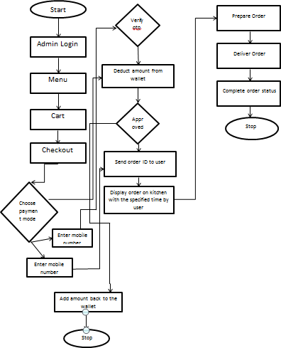

**Figure 4.1** System Architecture

#### UML Diagrams:

UML is a method for describing the system architecture in detail using the blueprint. UML represents a collection of best engineering practices that has proven successful in the modeling of large and complex systems. The UML is a very important part of developing object-oriented software and the software development process. The UML uses mostly graphical notations to express the design of software projects.

#### Use Case Diagram

Use case diagram represents the functionality of the system. Use case focus on the behavior of the system from an external point of view. Actors are external entities that interact with the system

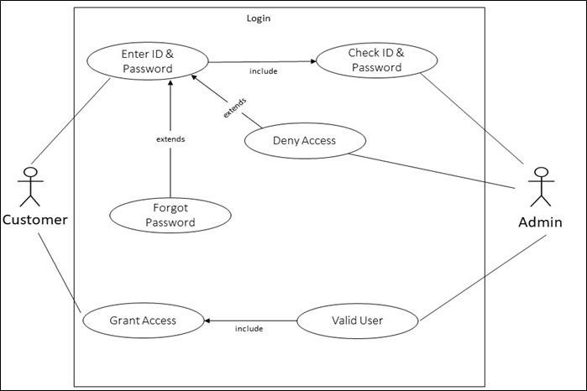Login:

Order and payment:

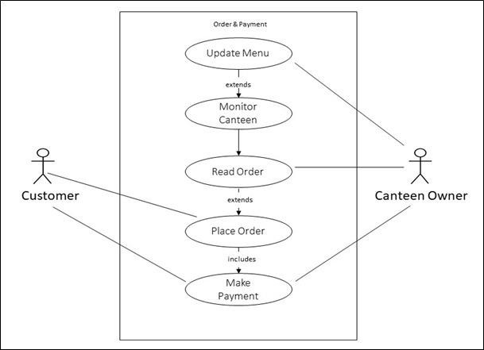

**Figure 4.2.1** Use Case Diagram

#### Use Cases:

A use case describes a sequence of actions that provide something of measurable value to an actor and is drawn as a horizontal ellipse.

#### Actors:

An actor is a person, organization, or external system that plays a role in one ormore interactions with the system. Four relationships among use cases are used often in practice.

#### Associations:

Associations between actors and use cases are indicated in use case diagramsby solid lines. An association exists whenever an actor is involved with an interactiondescribed by a use case. Associations are modeled as lines connecting use cases and actors to one another, with an optional arrowhead on one end of the line.

### CLASS DIAGRAM

In software engineering, a class diagram in the Unified Modeling Language (UML) is a type of static structure diagram that describes the structure of a system by showing the system's classes, their attributes, operations (or methods), and the relationships among the classes. It explains which class contains information.

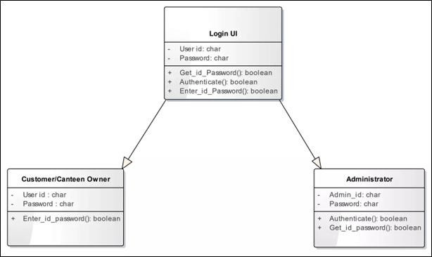

**Figure 4.2.2** Class Diagram

### ACTIVITY DIAGRAM

Activity diagrams are graphical representations of workflows of stepwise activities and actions with support for choice, iteration and concurrency. In theUnified Modelling Language, activity diagrams can be used to describe the business and operational step-by-step workflows of components in a system. An activitydiagram shows the overall flow of control.

##### Admin Activity Diagram:

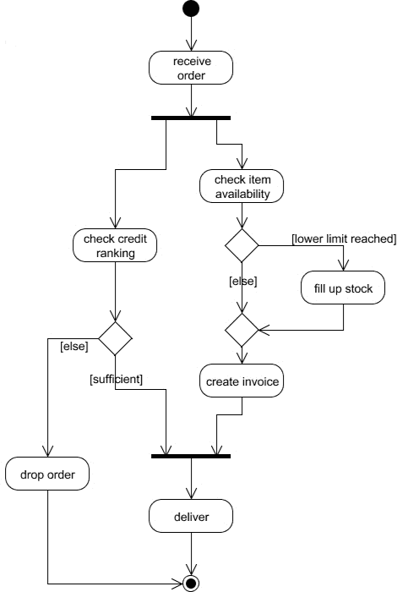

**Figure 4.2.3** Admin Activity Diagram

##### Login Activity Diagram:

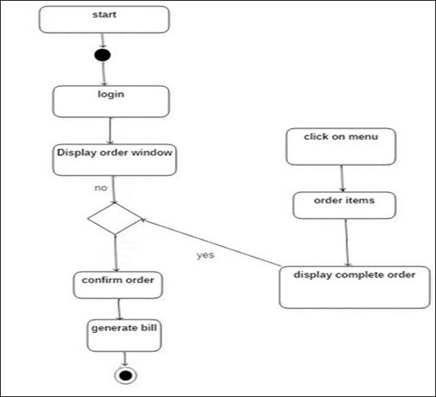

**Figure 4.2.4** Login Activity Diagram

### SEQUENCE DIAGRAM

**S**equence diagrams depict how objects or components interact over time, showcasing message sequencing and collaboration. They offer insights into a system's dynamic behavior, revealing the chronological flow of activities and dependencies between elements. Sequence diagrams are vital for modeling complex systems, understanding step-by-step processes, and identifying critical dependencies..

##### Admin Sequence Diagram:

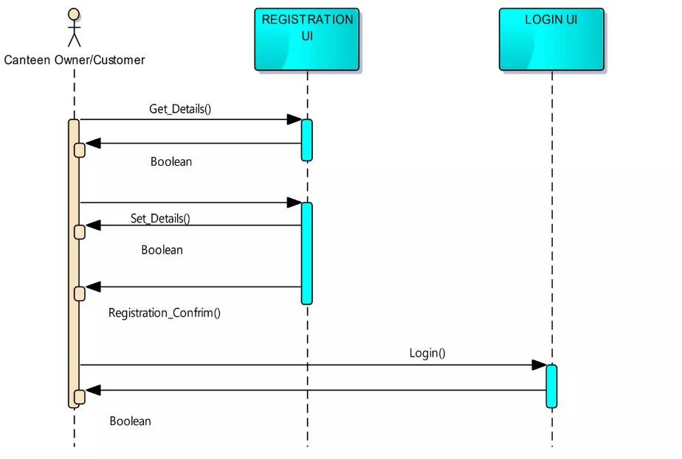

**Figure 4.2.5** Admin Sequence Diagram

##### Sequence Diagram for orders and payments:

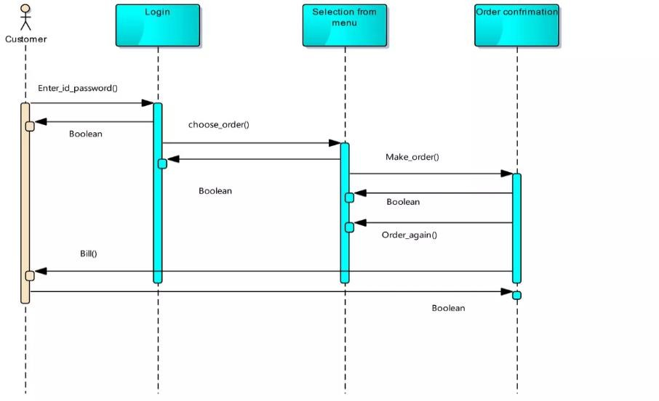

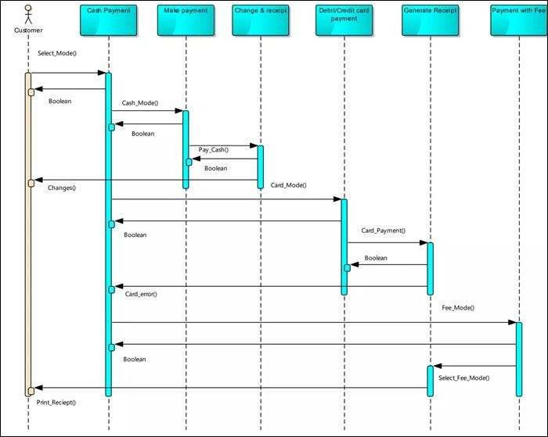

**Figure 4.2.6** Sequence Diagram for orders and payments

## CHAPTER-5 MODULES

##### Canteen Management Module:

* + - This module is responsible for managing canteen details, such as opening hours, location, and contact information.
    - It includes a menu management system to add, edit, and update food and beverage items available in the canteen.
    - Functionality for setting pricing and discounts should be included.

##### Sales Module:

* + - This module records and manages sales transactions.
    - It enables canteen staff to input orders, process payments, and generate invoices or receipts.
    - Sales data can be tracked for reporting and analysis.

##### Customer Module:

* + - This module stores and manages customer information.
    - Users, including students and faculty, should have profiles with details like name, ID, and contact information.
    - It can also include a loyalty program for rewarding frequent customers.

##### Employee Management Module:

* + - Manages information about canteen staff, including chefs, servers, and managers.
    - Records employee details, work schedules, and payroll information.
    - May include access controls for specific staff roles.

##### Item Module:

* + - This module manages the details of food and beverage items available in the canteen.
    - It includes item descriptions, prices, ingredients, and allergen information.
    - May allow for categorization of items (e.g., breakfast, lunch, beverages, snacks).

##### Stock Module:

* + - This module is responsible for managing inventory and stock information.
    - It tracks the quantity of items available, alerts for low stock, and generates purchase orders when necessary.
    - Helps in reducing food wastage and optimizing stock levels.

##### Login Module:

* + - Manages the authentication and access control for system users.
    - Provides a secure login system for canteen staff and administrators.
    - Ensures that only authorized personnel can access sensitive information.

##### Users Module:

* + - Manages the roles and permissions of different users within the system.
    - Assigns roles (e.g., admin, staff, customer) to control access to various modules.
    - Allows administrators to add, edit, or remove users from the system.

## CHAPTER-6 TECHNOLOGIES

### HTML

#### Introduction:

HTML (Hypertext Markup Language) uses a markup system composed of elements which represent specific content. Markup means that with HTML you declare what ispresented to a viewer, not how it is presented. Visual representations are defined by Cascading Style Sheets (CSS) and realized by browsers. Still existing elements that allow for such, like e.g. font, "are entirely obsolete, and must not be used by authors”.HTML is sometimes called a programming language but it has no logic, so is a markup language. HTML tags provide semantic meaning and machine-readability to the content in the page.

An element usually consists of an opening tag (**<element_name>**), a closing tag (**</element_name>**), which contain the element's name surrounded by angle brackets, and the content in between:

<element_name>...content...</element_name>.

#### Features of HTML:

**Ease of Learning and Use:** HTML is renowned for its simplicity, making it accessible to beginners. Its straightforward syntax and structure make it easy to grasp, making it a great starting point for web development.

**Platform Independence:** HTML is platform-independent, meaning web pages created in HTML can be accessed on various operating systems and web browsers. This universality ensures a consistent experience for users across different devices and platforms.

**Multimedia Integration:** HTML enables the seamless integration of multimedia elements, such as images, videos, and audio, enhancing the visual and interactive aspects of web pages. This capability is crucial for engaging content.

**Hypertext Functionality:** The "H" in HTML stands for "Hypertext," which allows for the inclusion of hyperlinks. You can create connections to other web pages, resources, or parts of the same page, fostering navigation and interactivity.

**Markup Language:** HTML is primarily a markup language, focused on structuring content. It uses

tags to define and describe different types of content, providing a hierarchical structure to web documents.

HTML's primary purpose is to create a structured representation of information, allowing for easy presentation and navigation on the web. The combination of semantic HTML elements, accessibility features, and integration with CSS and JavaScript makes it a versatile and essential tool for web development. In the following sections, we'll delve deeper into HTML's core concepts and explore how to create web pages using this markup language.

### CSS

#### Introduction:

Cascading Style Sheets (CSS) is a style sheet language used for describing thepresentation of a document written in a markup language such as HTML or XML.

CSS is designed to enable the separation of presentation and content, includinglayout, colors, and fonts. This separation can improve content accessibility; provide more flexibility and control in the specification of presentation characteristics; enable multiple web pages to share formatting by specifying the relevant CSS in a separate .css file, which reduces complexity and repetition in the structural content; and enable the .css file to be cached to improve the page load speed between the pages that share the file and its formatting.

The name cascading comes from the specified priority scheme to determine which style rule applies if more than one rule matches a particular element. This cascading priority scheme is predictable.

#### Features of CSS:

Cascading Style Sheets (CSS) is a fundamental technology in web development, allowing for the separation of content and presentation. It enhances accessibility by enabling text resizing, alternative image descriptions, and adaptable layouts for diverse users, including those with disabilities. CSS offers flexibility and fine-grained control over the visual aspects of web elements, fostering creativity in design. It encourages shared styling through external files, enhancing efficiency and consistency. Cached external CSS files lead to faster load times for frequently visited pages. The predictable cascading priority scheme resolves style rule conflicts efficiently. CSS's extensive styling capabilities encompass colors, fonts, text alignment, borders, spacing, and layout, catering to diverse design

needs. Furthermore, CSS extends its reach beyond visual styles by defining non-visual attributes, promoting web content accessibility for users relying on screen readers and other assistive technologies. In summary, CSS empowers web developers to create visually appealing, accessible, and consistent web content, making it an indispensable part of modern web design.

#### Django

Django is a popular open-source web framework for Python that simplifies web application development. It follows the Model-View-Controller (MVC) architectural pattern and includes a robust Object-Relational Mapping (ORM) system, an admin interface for easy data management, URL routing, and a powerful templating engine. With built-in features for authentication, security, and form handling, Django streamlines the development process. Its active and supportive community, along with extensive documentation, makes it an excellent choice for building web applications of all sizes and complexities. Whether you're a novice or an experienced developer, Django's "batteries-included" approach and adherence to best practices make it a go-to framework for creating web applications efficiently and securely.

#### Xampp &PHP

PHP (Hypertext Preprocessor) is a widely used, server-side scripting language designed primarily for web development. It is known for its versatility and ease of use, making it a popular choice for building dynamic web applications and websites. PHP scripts are embedded within HTML, allowing developers to mix logic with presentation seamlessly. With an extensive community and a wealth of open-source libraries and frameworks, PHP offers a robust ecosystem for web developers. Although it has faced criticisms for certain aspects of its design, PHP remains a workhorse in web development, powering countless websites and web applications across the internet. It's known for its rapid development capabilities and compatibility with various web servers and databases, making it a valuable tool for a wide range of web projects.

XAMPP is a widely-used, open-source software stack that simplifies the process of setting up a local web server environment for development and testing purposes. The name "XAMPP" stands for the components it includes: X (cross-platform), Apache (web server), MySQL (database), PHP (scripting language), and Perl. XAMPP is available for multiple operating systems, including Windows, macOS, and Linux, making it a versatile tool for web developers. It provides an all-in-one package, allowing users to install and configure Apache, MySQL, PHP, and other related tools with minimal effort. This local development environment is invaluable for testing web applications before deploying them to a live server, as it closely mirrors a production environment. Moreover, XAMPP is user-friendly, making it accessible to both beginners and experienced developers seeking a convenient and efficient way to work on web projects offline.

# CHAPTER-7

# IMPLEMENTATION

**7.1.Coding**

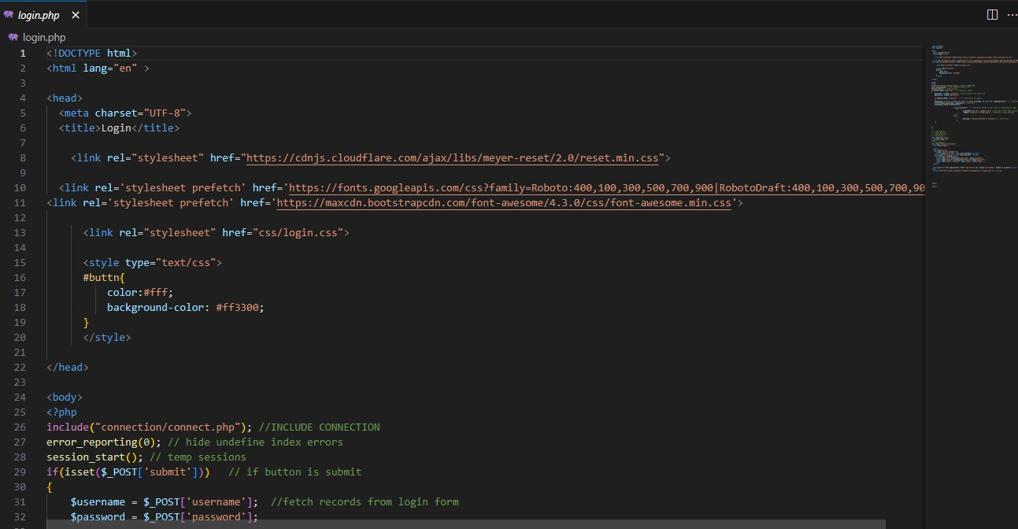

Fig:Login.PHP

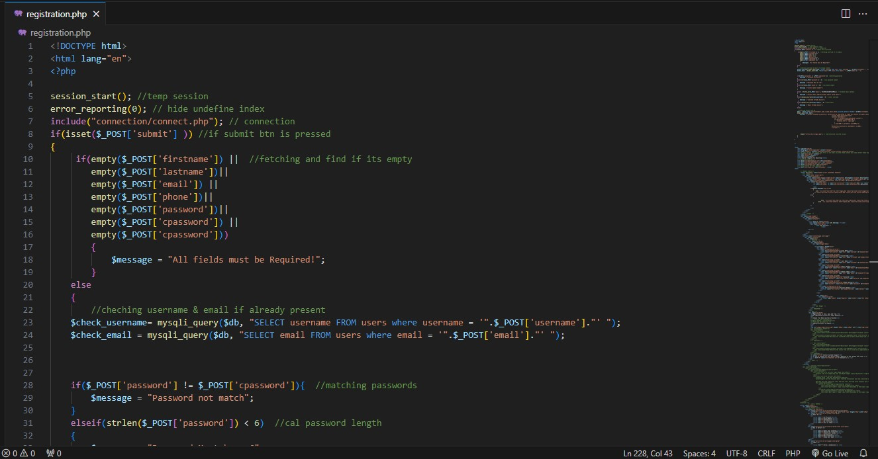

Fig:Registration.PHP

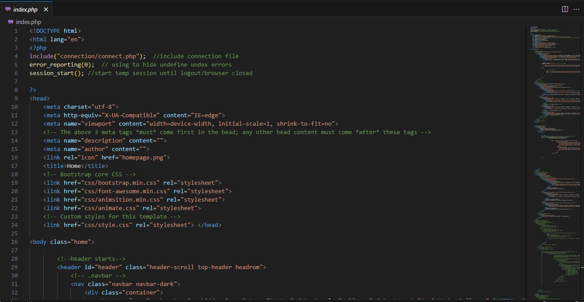

Fig:Index.PHP

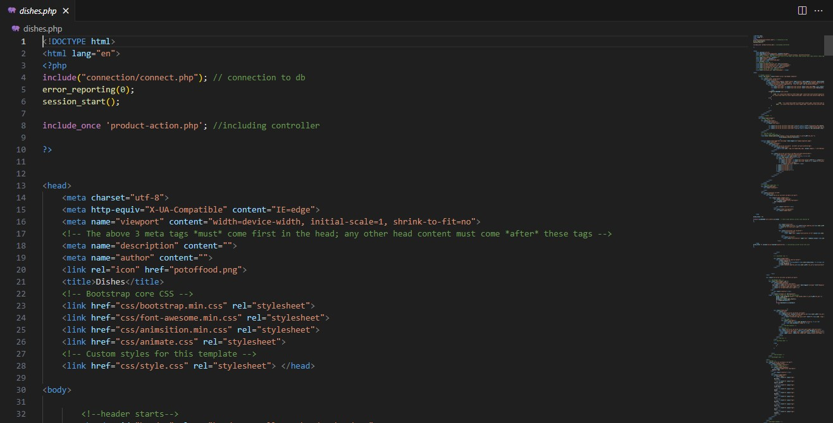

Fig:Dishes.PHP

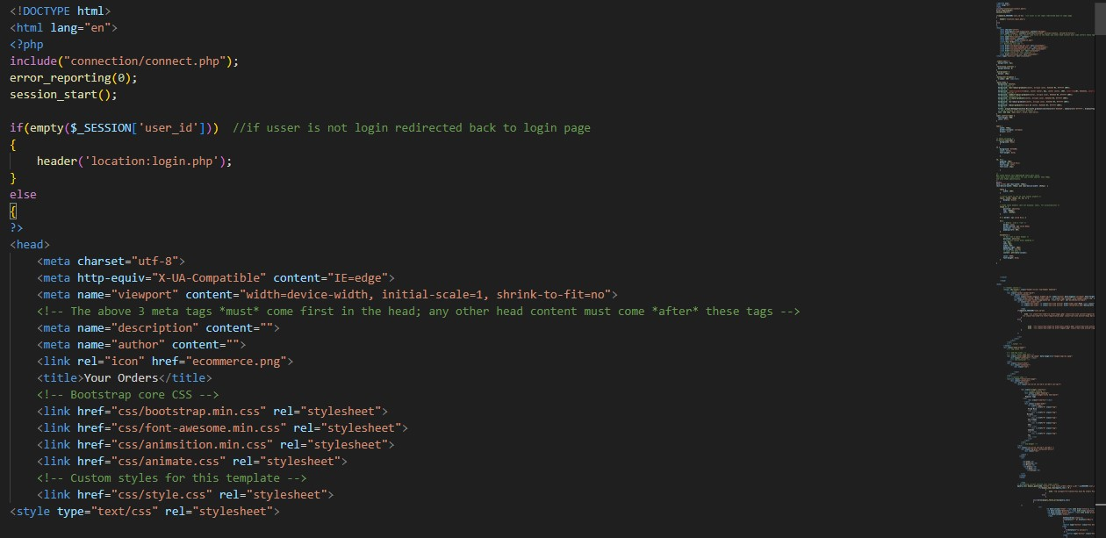

Fig: Orders.PHP

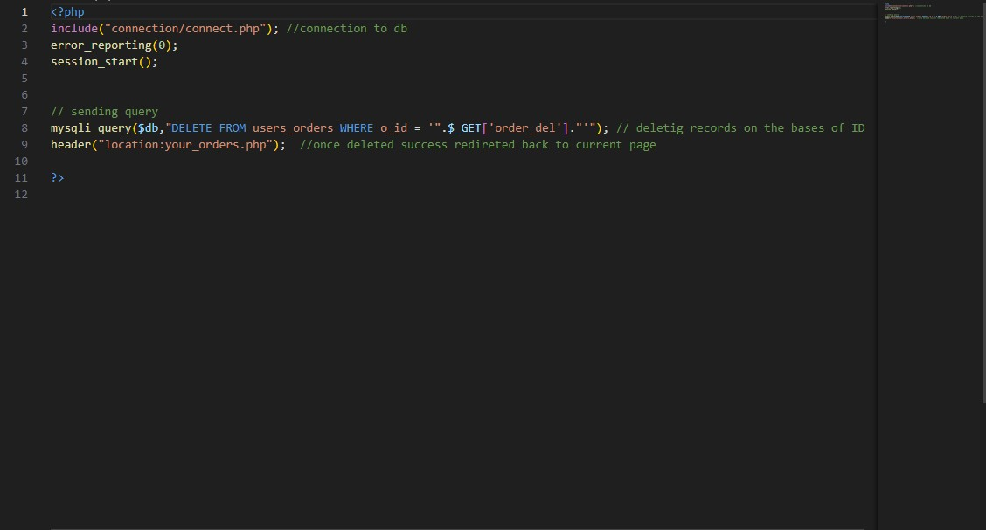

Fig: DeleteOders.PHP

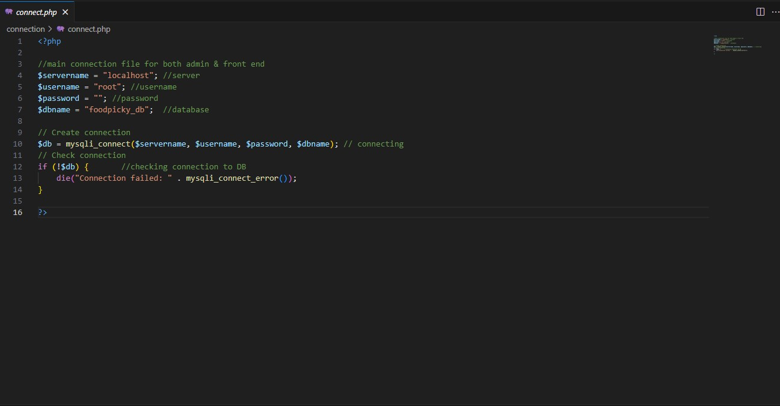

Fig: Connect.PHP

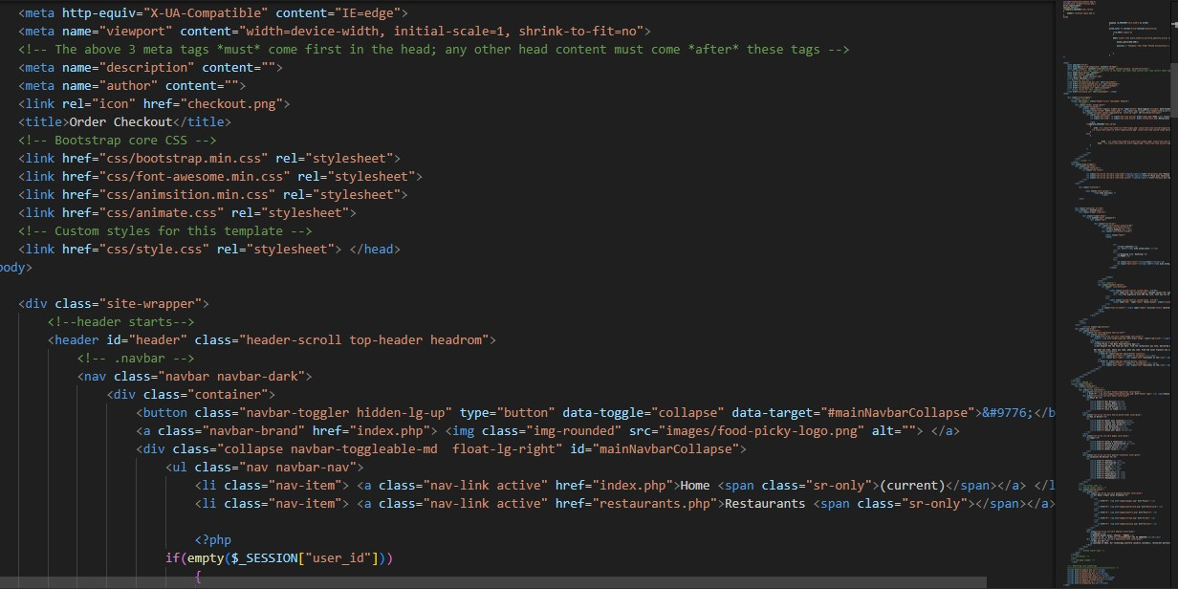

Fig: Checkout.PHP

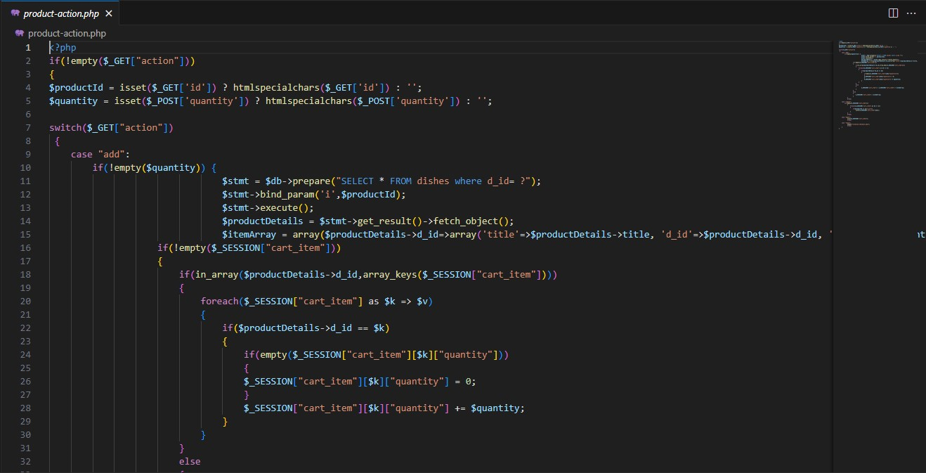

Fig: Product-actions.PHP

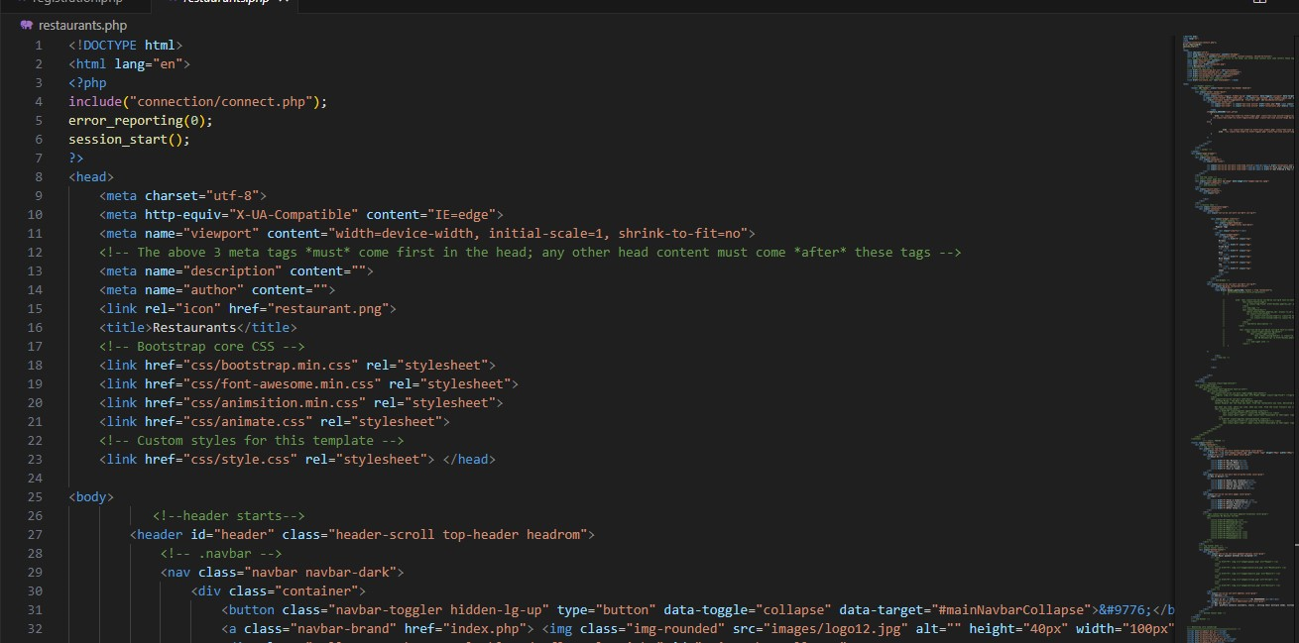

Fig: Restaurant.PHP

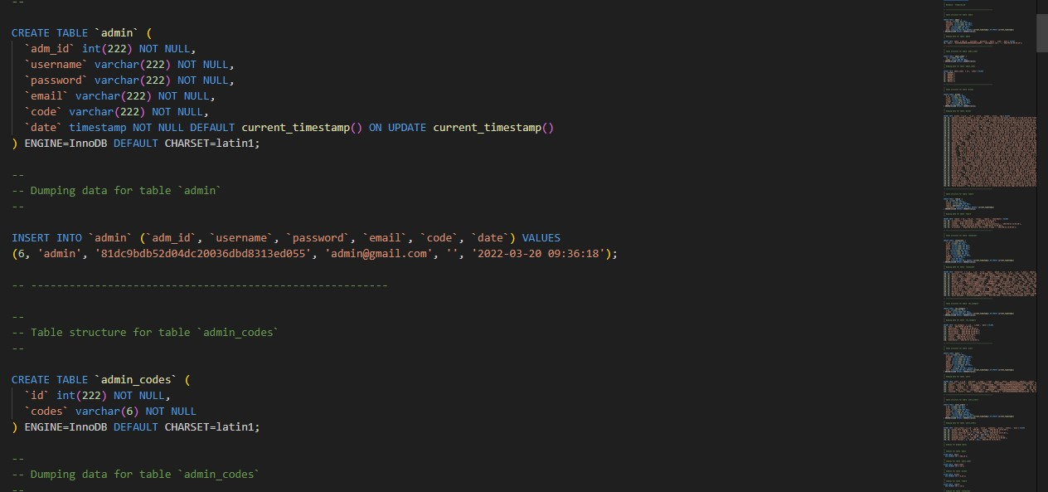

Fig:Database.PHP

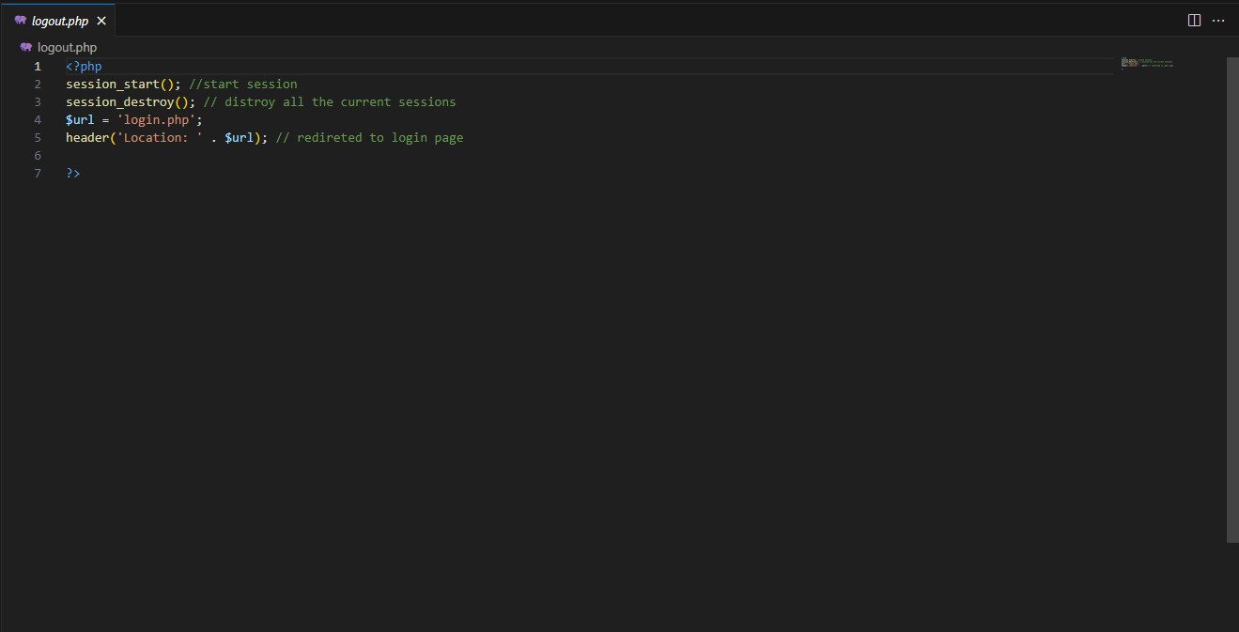

Fig: Logout.PHP

# CHAPTER-8

# TESTING

#### 8.1.Functional Testing:

* Testing each feature of the canteen management system to ensure they work as per the requirement. This includes user registration, menu management, order placement, payment processing, etc.
* Verifying that user roles (admins, staff, and customers) have appropriate access and permissions.

#### 8.2.Performance Testing:

* Testing the system's performance under various conditions (e.g., heavy user load, peak hours).
* Checking response times and system stability.

#### 8.3.Usability Testing:

* Evaluate the user interface for usability and user-friendliness.
* Ensure that the system is intuitive for both staff and customers.

#### 8.4.Compatibility Testing:

* Verifying that the canteen management system works correctly on different devices and web browsers.
* Ensure compatibility with different operating systems and hardware architectures.

#### 8.5.Integration Testing:

* Testing the integration of various components, such as the menu database, payment gateway, and user management system etc.

**8.6 .Test Cases:**

|  |
| --- |
|  |

# CHAPTER-9 SCREENSHOTS

**USER SIDE – INTERFACE , LOGIN , REGISTRATION , STALLS & ORDERS**

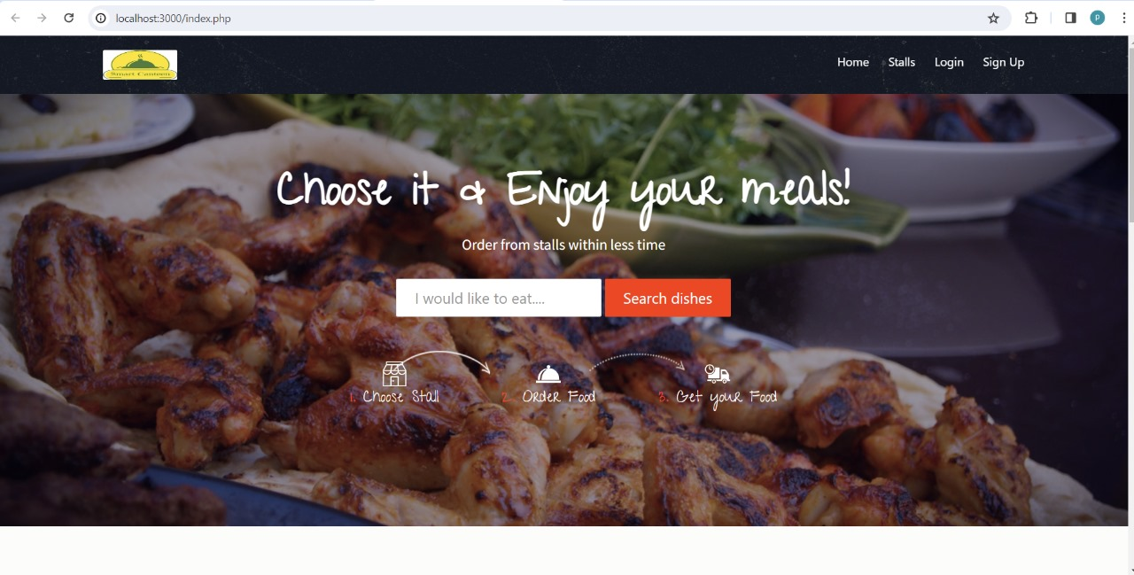

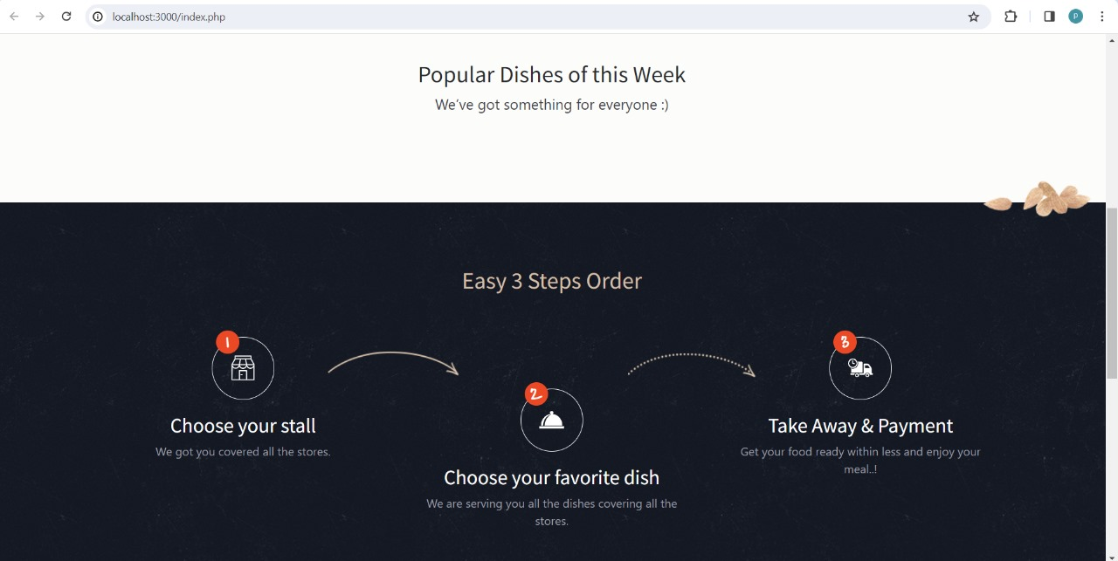

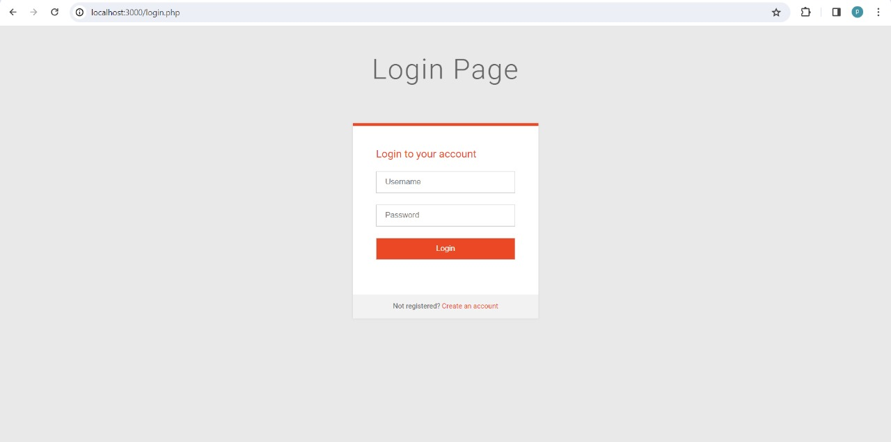

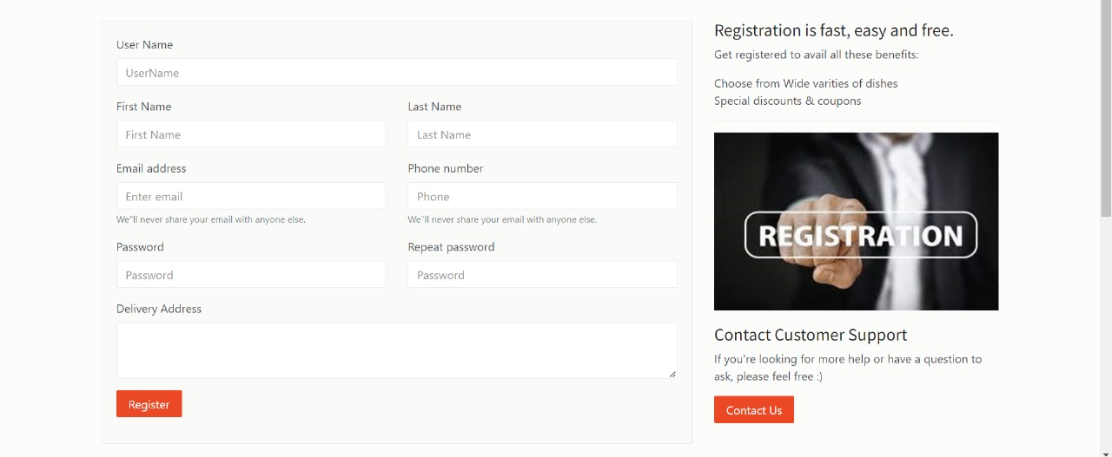

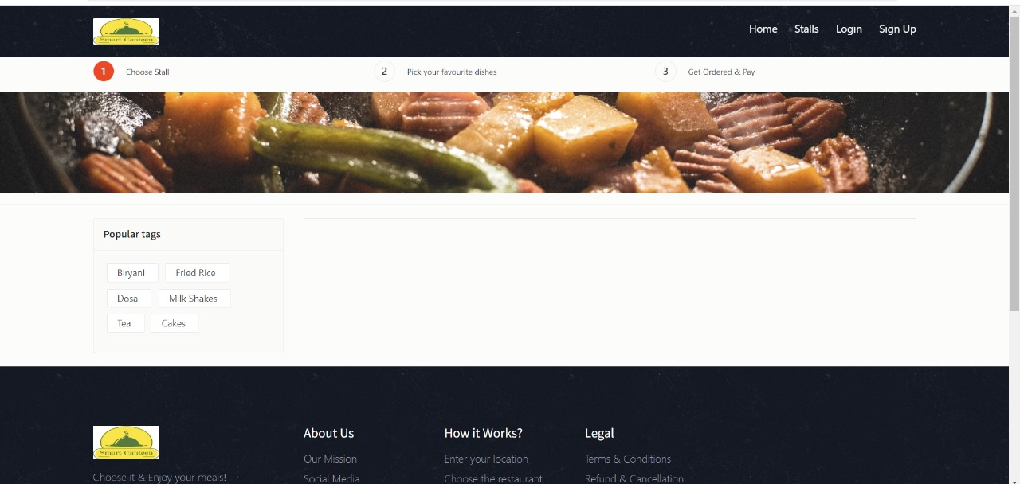

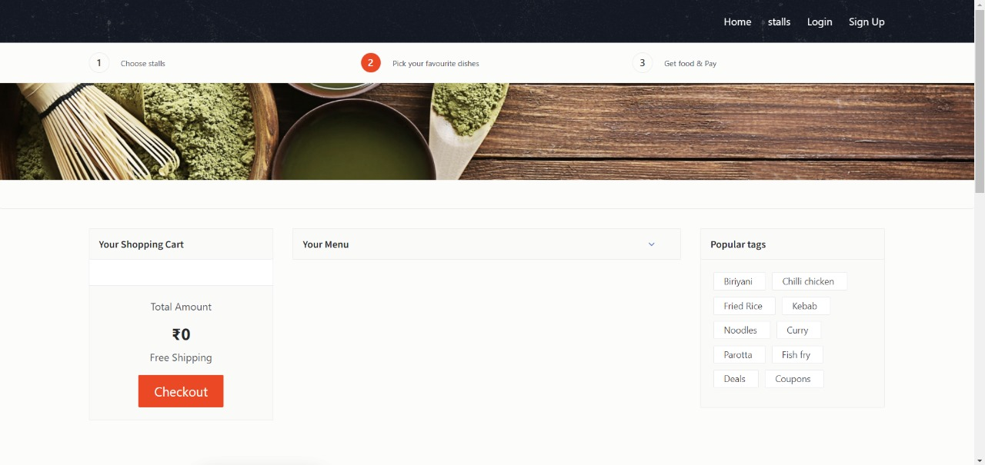

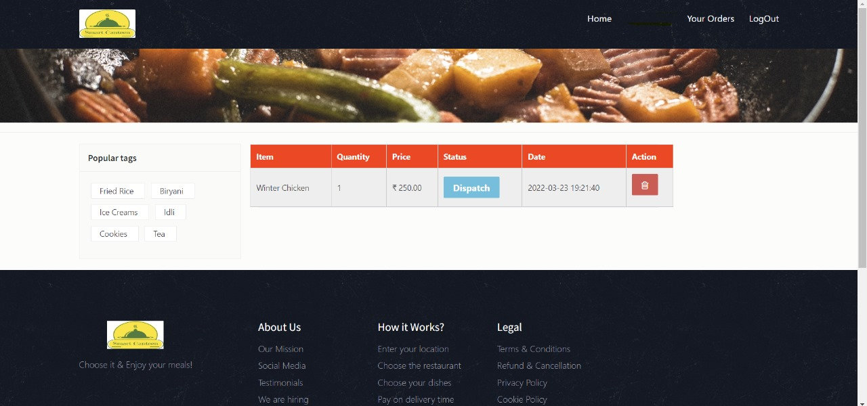

**ADMIN SIDE** :

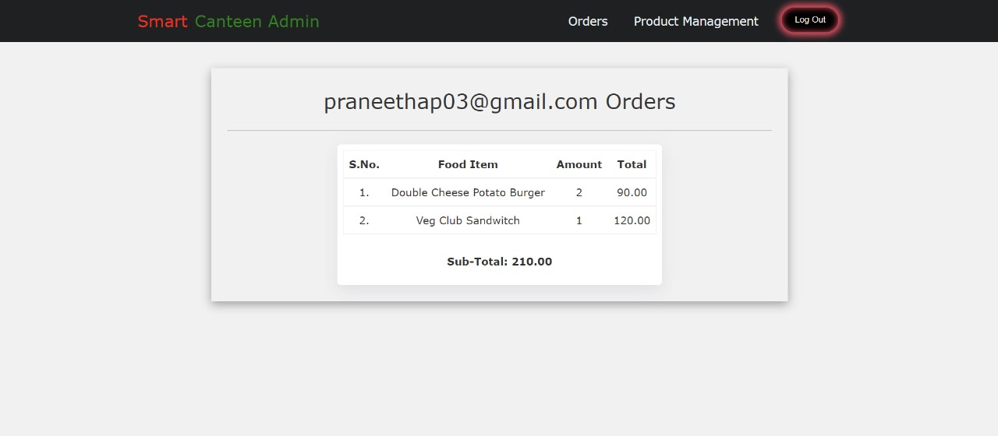

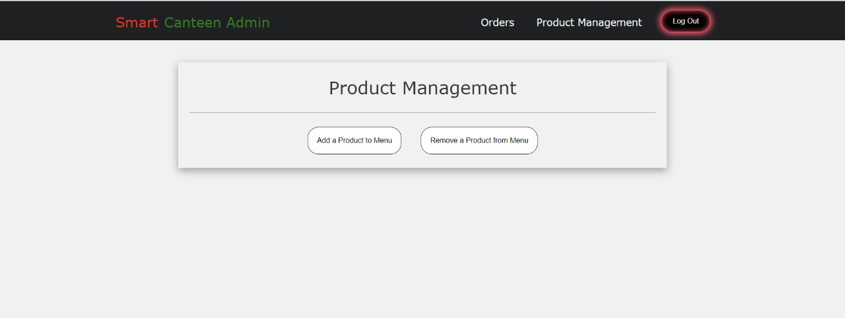

# CHAPTER-10

# CONCLUSION AND

# FUTURE WORK

**Conclusion:**

The "Smart Canteen Management System" offers a modern, efficient, and scalable solution for enhancing the dining experience in educational institutions. With reduced waiting times, improved resource utilization, and increased user satisfaction, the system aligns with the broader trend of leveraging technology for institutional modernization.

**Future Work:**

1. Enhanced Personalization: Refine personalized recommendations based on user preferences.

2. Integration with Health Tracking: Explore features for nutritional insights and diet tracking.

3. Feedback Mechanism: Implement a robust feedback system for continuous improvement.

4. Environmental Impact: Consider sustainability practices to reduce the environmental footprint.

5. Advanced Analytics: Improve data analytics for better insights into user behavior.

6. Integration with Academic Systems: Sync with academic schedules for optimized service.

7. Mobile App Features: Expand mobile app functionalities for a streamlined user experience.

**CHAPTER-11**

**REFERENCES**

1. Ms. S.A.Patil 1, Janhavi. B. Sutar 2 , Sakshi. Y(2021) “AUTOMATED CANTEEN MANAGEMENT

SYSTEM”- , International Research Journal of Modernization in Engineering Technology and Science , Volume:03.

1. Ms.Minu, Kowshik reddy, Sumanth Ashik Teja (2018) “ONLINE CANTEEN SYSTEM” Computer Science and Engineering ,SRM Institute of Science and Technology, Ramapuram, Chennai, India , 2018 JETIR October 2018, Volume 5, Issue 10.
2. Tazeen Khan, Daniel Yunus “Cloud Based Canteen Management System” , International Journal for Research in Engineering Application & Management (IJREAM), Vol-02, Issue 08, Nov 2016.
3. Rupali B. Kale , Ruchika K. Balwade, Vipin B. Gawai(2020) “Online Food Ordering System for College Canteen”, RESEARCH ARTICLE SAMRIDDHI Volume 12, Special Issue 2.
4. Shourya Pradhan, Shubham Jain ,Shubhanshu Pratap Singh, Yash Gupta (2019)“Canteen Management App”,International Journal of Information Sciences and Application (IJISA). ISSN 0974-2255, Vol.11, No.1, 2019.
5. Arfa Hassan , Salma Rashid , Raheela Khan , Shazia Saqib “Automated Food Ordering System”, Lahore Garrison University, Lahore, Pakistan. University of Management and technology Lahore, LGU Research Jounral for Computer Sciences & IT Vol. 2 Issue 4, October - December 2018.
6. N. Durga Swathi & T. Durga “ONLINE CANTEEN FOOD ORDERING SYSTEM”, VSM College of Engineering, East Godavari District, Andhra Pradesh, India, AEGAEUM JOURNAL Volume 8, Issue 8, 2020 ISSN NO: 0776-3808.
7. B Muniraja , J Rajanikanth - In - Time Billing Process for Canteen Management System - International Journal of Emerging Trends in Engineering Research (IJETER), Vol. 3 No.6, Pages : 200 - 203 (2015) .
8. Ashwini J, Ayisha Shetty, Chaithra, Lasya K Rao,Asst. Prof. Ramya D Shetty(2018) “Automated Food Ordering System”, International Journal of Scientific & Engineering Research Volume 9.

[10] Suman Chatterjee,Manish Kumar Thakur's "Smart College Management System" is featured in the IJERT . This Android-based app simplifies college tasks for administrators, faculty, and students, reducing paperwork and enhancing the college experience.